Task No 01: Design a web page using Headings H1 to H6.

Input:

<html>

<P> There are six levels of heading in HTML. The lower the number, the larger the header will be. Thus, H1 is the largest header, and H6 is the smallest</P>

<h1> Heading 1</h1>

<h2> Heading 2</h2>

<h3> Heading 3</h3>

<h4> Heading 4</h4>

<h5> Heading 5</h5>

<h6> Heading 6</h6>

</html>

Output:

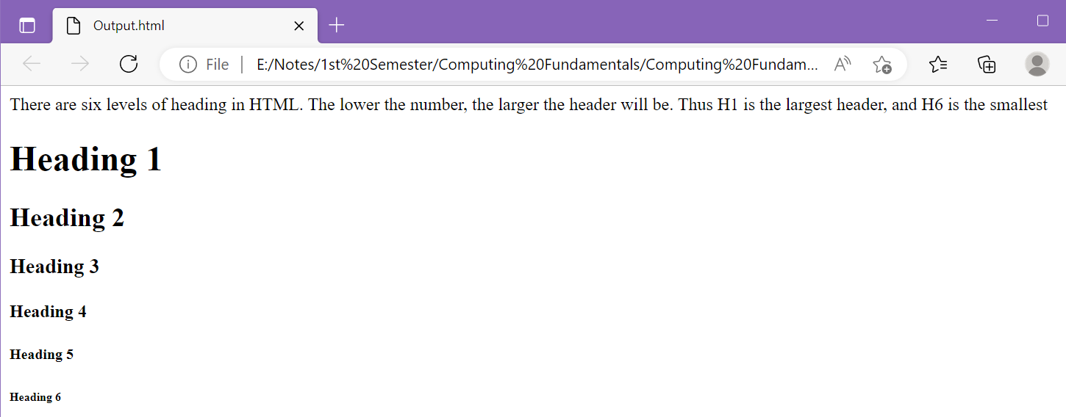

Task No 02: Design a web page using Center tag.

Input:

<html>

<h4><center>THE CENTER TAG</center></h4>

<P><CENTER>My Name is Abdullah sadiq.</CENTER></P>

</html>

Output:

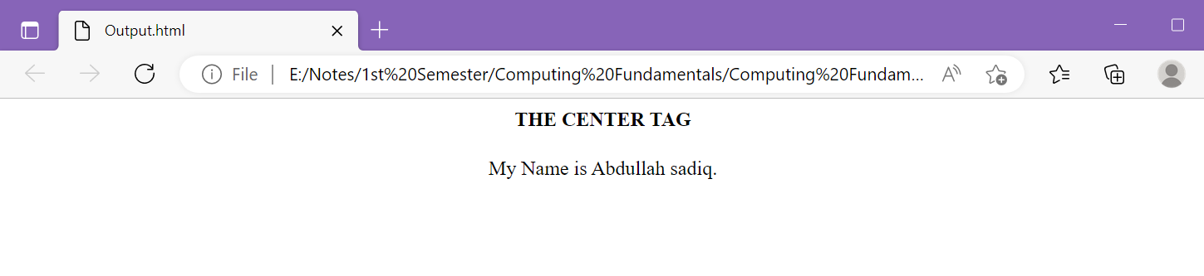

Task No 03: Create a Hyperlink and Navigate to it from your web page.

Input:

<html>

<h2 style="color:(black);font-style:normal"><center>ABDULLAH SADIQ</center></h2>

<P style="color:(black);font-style:normal"><center> -All the Social Media Handles- </center></P>

<p><center> <a href="https://www.instagram.com/as.captures._/?igshid=YmMyMTA2M2Y%3D">Instagram</a></center></p>

<p><center> <a href="https://www.facebook.com/AS.Capturess">Facebook</a></center></p>

<p><center> <a href="https://www.linkedin.com/in/iabdullahsadiq">LinkedIn</a></center></p>

<p><center> <a href="https://www.snapchat.com/add/iAbdullahSadiq">Snapchat</a></center></p>

</html>

Output:

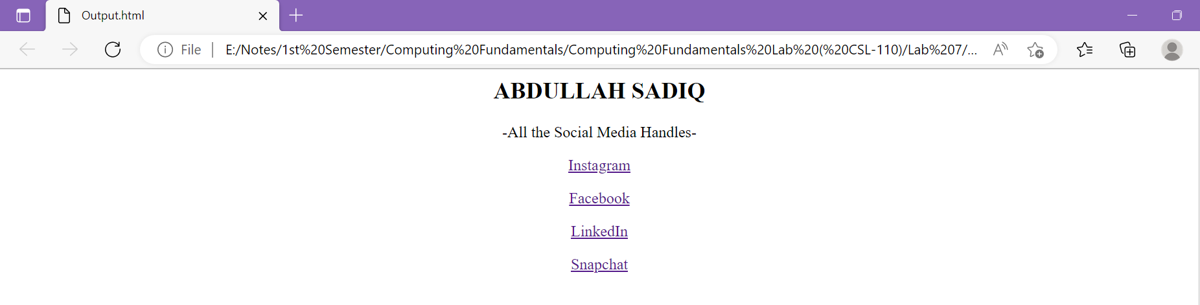

Task No 04: Design Tables using Row Span along with Table tag.

1. Input:

<html>

<table border="1">

    <tr>

        <td>Num 1</td>

        <td rowspan= "2" bgcolor="green"> Num 2</td>

        <td>Num 3</td>

    </tr>

    <tr>

        <td> Num 4</td>

        <td> Num 5</td>

    </tr>

</table>

</html>

1. Output:

1. Input:

<html>

<table border="1">

    <tr>

        <td rowspan= "2" bgcolor="green">Num 1</td>

        <td> Num 2</td>

        <td>Num 3</td>

        <td> Num 4</td>

    </tr>

    <tr>

        <td> Num 5</td>

        <td> Num 6</td>

        <td> Num 7</td>

    </tr>

</table>

</html>

1. Output:

Task No 05: Design Tables using Col Span along with Table tag.

1. Input:

<html>

<table border="1">

    <tr>

        <td>Num 1</td>

        <td colspan= "2"> Num 2</td>

    </tr>

    <tr>

        <td> Num 3</td>

        <td> Num 4</td>

        <td> Num 5</td>

    </tr>

</table>

</html>

1. Output:

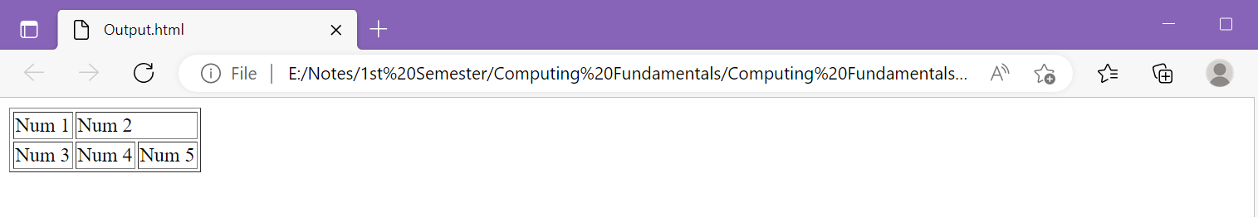

1. Input:

<html>

<table border="1">

    <tr>

        <th colspan="2">Heading 1</th>

        <th colspan="2">Heading 2</th>

    </tr>

    <tr>

        <td>A</td>

        <td>B</td>

        <td>C</td>

        <td>D</td>

    </tr>

    <tr>

        <td>E</td>

        <td>F</td>

        <td>G</td>

        <td>H</td>

    </tr>

</table>

</html>

1. Output:

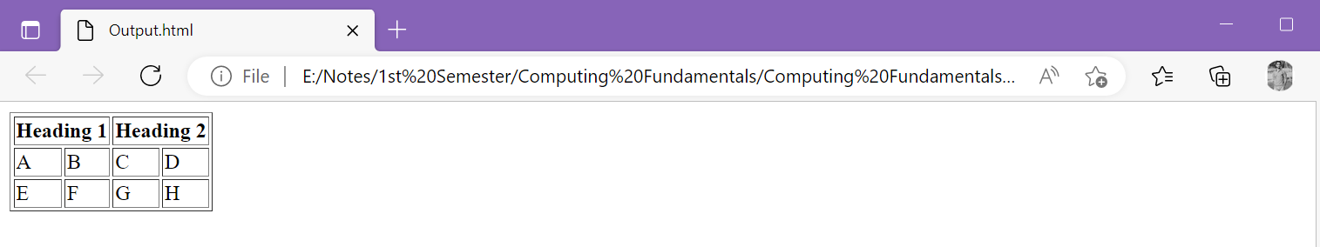

1. Input:

<html>

<table border="1">

    <tr>

        <th colspan="2">Heading 1</th>

        <th colspan="2">Heading 2</th>

    </tr>

    <tr>

        <th>Heading 3</th>

        <th>Heading 4</th>

        <th>Heading 5</th>

        <th>Heading 6</th>

    </tr>

    <tr>

        <td>A</td>

        <td>B</td>

        <td>C</td>

        <td>D</td>

    </tr>

    <tr>

        <td>E</td>

        <td>F</td>

        <td>G</td>

        <td>H</td>

    </tr>

</table>

</html>

1. Output:

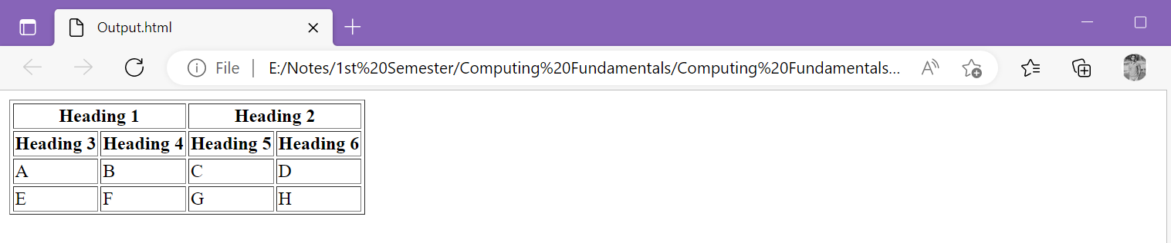

Task No 06: Design a Table using BG Color attribute, along with Row Span and Col Span.

Input:

<html>

<table border="1">

    <tr>

        <td rowspan="3" bgcolor="Pink">Pink</td>

        <td colspan="3" bgcolor="Red"><center>Red</center></th>

    </tr>

    <tr>

        <td bgcolor="Green">Green</td>

        <td bgcolor="Yellow">Yellow</td>

        <td>White</td>

    </tr>

    <tr>

        <td colspan="3" bgcolor="Purple"><center>Purple</center></td>

    </tr>

    </table>

</html>

Output:

